Introduction

Eyedrivomatic is a system which allows users of existing eyegaze systems to drive their wheelchair with just eye control. The current beta system has been extensively tested and developed to the stage where it is now successfully used daily by several users.

The philosophy behind Eyedrivomatic is that it can be used on a wide range of wheelchairs, but each wheelchair controller can have different settings programmed and this will partially determine how the Eyedrivomatic system will function. Also the type of wheelchair (rear, mid or front wheel drive) will also have different driving characteristics .

The testing location should be suitably spacious. We appreciate the potential difficulties of outdoor testing; too sunny for eyegaze, too cold, internet access problems, but empty car parks are ideal locations. We strongly recommend no testing is done without a carer present.

Prerequisites

The Eyedrivomatic system requires an existing wheelchair mounted eyegaze system running Windows and a free USB socket, The Grid 2 application installed (see below), a powered wheelchair with a standard joystick either mounted on the armrest (some rear mounted attendant controllers may also work).

Hardware and Software

The hardware comprises of 5 components; the mechanical hand, the locator plate, the "mushroom", or joystick sleeve, (the post that replaces your joystick top), the "brain box" and a power pack

Currently the system only works in conjunction with The Grid 2 AAC software. A trial version is available for 60 days from https://thinksmartbox.com/downloads/the_grid_2/
A stand alone version will be available soon which will run without any additional software. The software comprises of 3 elements; the driving grids for The Grid 2 software, the control application for your PC which appears above the grid and the brain box firmware, an Arduino program which is uploaded to the brainbox. If you received your Eyedrivomatic system pre assembled, the firmware will be preloaded. If you assembled the system yourself, you will need to download the latest firmware as described below.

If at any point these instructions don’t correlate with your system or wheelchair behaviour, or if you're confused about anything, please contact us at the Hackaday website.

Preparation
Once you have received your pre assembled Eyedrivomatic system or assembled your own and downloaded & installed The Grid 2 application, you will need to download two (or three if you self assembled) elements of the software.

The 3 grids
can be downloaded from https://github.com/Patrick-Joyce/Eyedrivomatic-github/tree/master/grid%202%20grids%20for%20eyedrivomatic%20pure

brain box firmware arduino 1A. This is the firmware. Your Eyedrivomatic will come pre loaded with the firmware if it was pre assembled, but if you did a self assembly you will need to download the latest firmware from https://github.com/Patrick-Joyce/Eyedrivomatic-github/tree/master/Software/eyedrivomatic_pure_arduino_firmware

Eyedrivomatic PC Application
This can be downloaded from https://github.com/Patrick-Joyce/Eyedrivomatic-github/tree/master/Software/eyedrivomatic_pure_PC_software
Currently the pc application needs personalising, depending on which com port your pc assigns the brain box to. If you are familiar with using 'Processing' and the arduino ide, then you will find the relevant part to alter on line 56 of the code. Where it says “COM26”. If, on the other hand, you don't know what i'm talking about, then contact us via the hackaday page and we will prepare your copy of the pc application for you. This is a temporary situation. The eyedrivomatic project has recently aquired its very own computer programmer! So hopefully we'll iron out the software complications soon.
Software setup and initial lap testing

We recommend that before you strap the electronic hand to your chair, that you get it all setup and working with the system sat on your lap. Nice and safe. That way you can get used to the system without worrying about crashing.
Setting up the system

- Sit the Brain Box and Electronic Hand on your lap.
- Connect the servo cables on the electronic hand to the corresponding cables from the brainbox, ensuring the top servo is connected to Y and the lower servo is connected to X. Also IMPORTANT ensure the connections are made so the cables wire colours match.
- Connect the 2 control wires between the brainbox and the controller's buddy button sockets (if your chair has them. If not don't worry), removing any existing buddy button plugs in the process. Socket 1 on brainbox should be connected to the controller's on off buddy socket and socket 2 should be connected to the controller's mode socket.
- On the brain box. Connect the PC usb cable to a usb socket on your chair mounted PC. Connect the servo power usb cable to the battery pack, and turn the battery on. (ensure it's fully charged)

Depending on your familiarity with configuring The Grid, you might need to contact us via the Hackaday website to setup links for the Eyedrivomatic grids

If you’re familiar with The Grid configuration, the grids you downloaded earlier need to be copied to your user's grid folder. Then a cell needs to be added to one of your choice of existing grids. This cell needs 4 commands assigned to it; switch to computer control environment, launch the application from the folder you downloaded the Eyedrivomatic application to, including the application name complete with the .exe extension . In the field uNext add a jump to the "eye Eyedrivomatic pure setup" grid and dock current window. Once done please test all grids and especially the "save settings and exit" and "jump back" cells to ensure you're returned correctly to your normal grid operation. THIS IS VERY IMPORTANT.

Grid Explanation

There are currently three different grids. These are constantly evolving and may not look exactly like these screenshots.

Setup grid

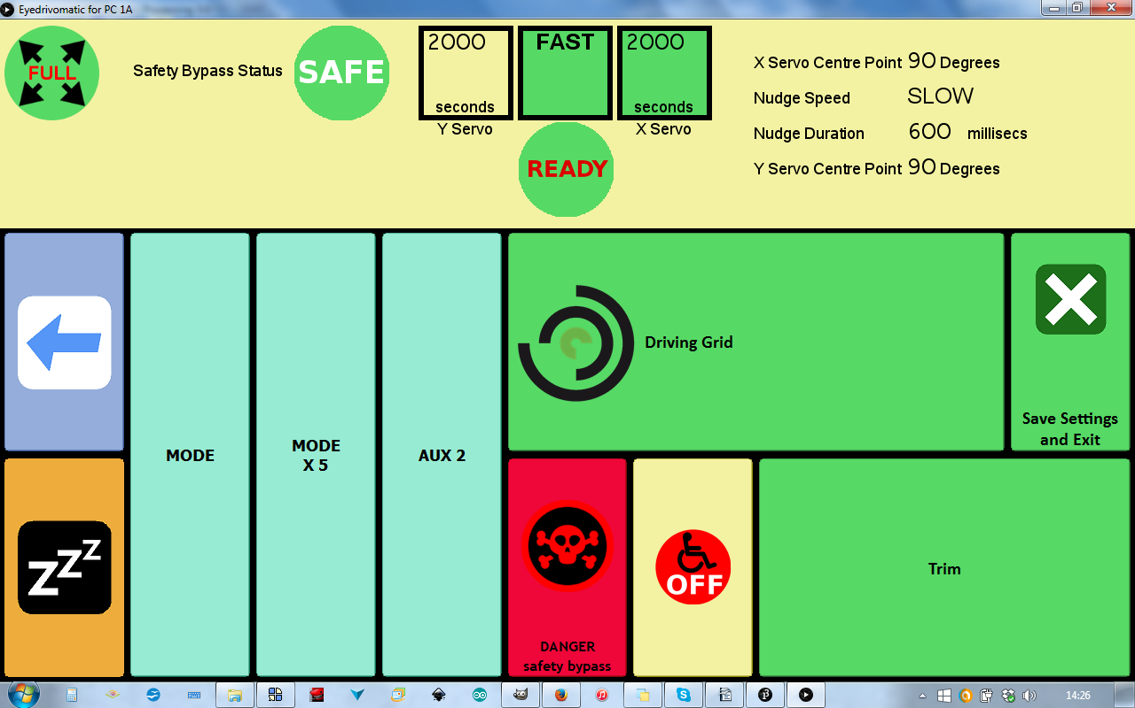

This is the landing grid from your existing gridset. It should have the status window docked above it. From here you can select your wheelchair's controller speed and mode, access the driving and the trim grid.

Back: back to your system without closing the application

Rest: all inputs rested

4 Mode cells: mode selects next wheelchair mode or speed, mode x 5 cell advances 5 modes or speeds. Aux is the output 3 cell, use this to switch anything of your choice.

Safety mode: Selects whether safety mode is on or off

Wheelchair on/off: Does what it says on the tin

Driving grid: self explanatory

Trim: Grid to make fine positioning adjustments to the centre position of the electronic hand

Save and exit: Saves your current settings, closes application and returns to your gridset

Safety mode

This allows or permits the repetitive pressing of a driving button e.g. forward followed by forward again. When safety mode is on, the continue button has to be pressed in alternation with a direction button. This prevents the situation where eyegaze contact is lost, causing the cursor to repeatedly press a direction button, and driving the wheelchair without your input. Driving with safety mode off is simpler but risky outside especially when it's sunny. The current safety mode is shown to the left of the turn duration in the status window.

Status Window

Above every Eyedrivomatic grid is a status window. This is a vital source of information and MUST be checked every time before driving.

The central 3 boxes report form left to right, the duration in milliseconds of left and right buttons, the speed for forwards, backwards and diagonal movements, and the duration in milliseconds of the forwards, backwards and diagonal buttons.

In the top left corner is the Diagonal Speed Indicator, Full for tighter turning, Reduced for gentler turning.

To the right of the Diagonal Speed Indicator is safety mode indicator.

Beneath the Eyedrivomatic speed is the Driving Status. When safety mode is off, it will permanently ready READY. With safety mode on, there are 3 states: READY ready to drive, CONTINUE press the continue button to keep proceeding, RESET press reset button to return to READY.

On the right are your current nudge and trim settings.

Driving grid

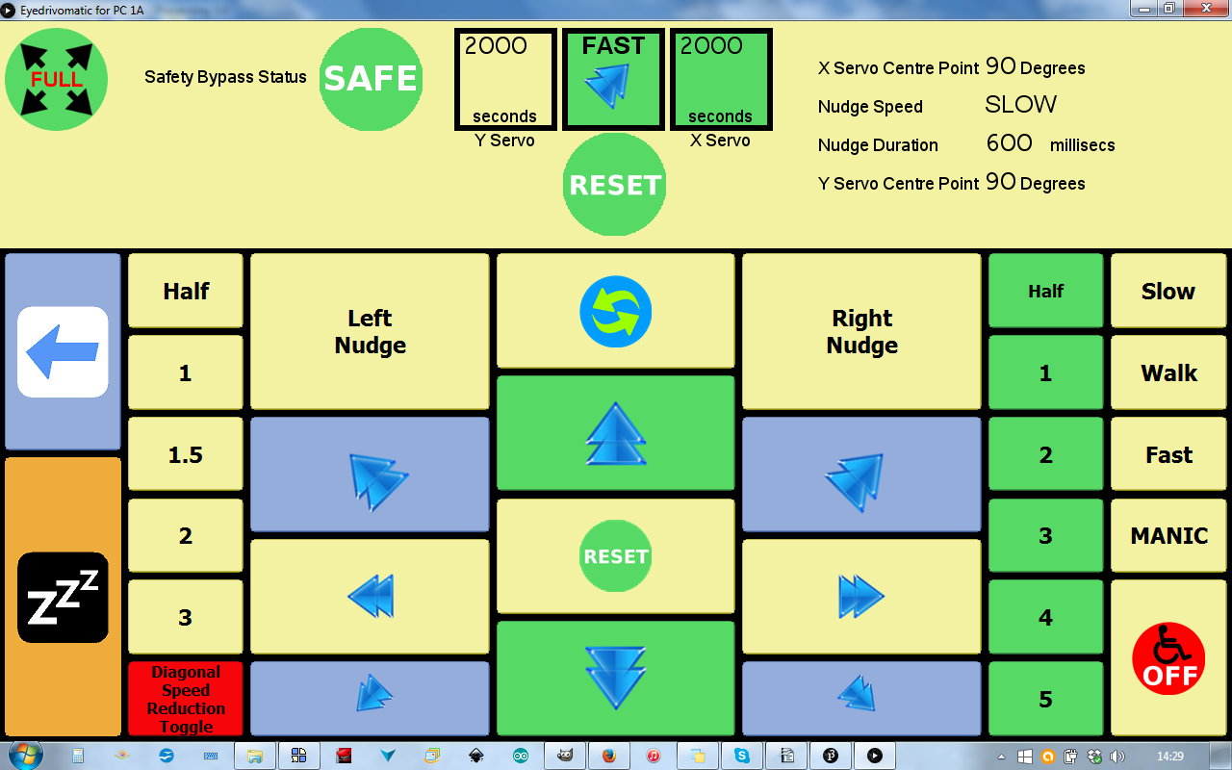

On the right are the available speed settings for forwards, backwards and all diagonals.

Left and right speeds are constant across all speeds and will eventually be user settable in the trim menu.

The speed settings determine the degree of mechanical hand movement , and in conjunction with your controller speed, determines how fast you move.

The green duration buttons select how long forwards, backwards and all diagonals last with one direction button press before the joystick returns to the centre.

The yellow duration buttons on the left select how long right and left movements last with one direction button press before the joystick returns to the centre.

The reset button will instantly cancel any joystick movement.

The continue button above the forward button only functions in safety mode and needs to be pressed alternatively with direction buttons when safety mode is on.

The duration setting will partly determined by your eyegaze dwell time, if you use dwell selection. To make smooth progression you will need to select a green duration longer than you dwell time.

The nudge buttons are used in conjunction with the forward button. Once setup correctly, the wheelchair should maintain a straight course but terrain will cause the wheelchair to veer occasionally and the nudge buttons will correct this. The amount and duration of the nudge can be set in the trim grid.

The "diagonal speed reduction toggle" button changes the severity of the diagonal movements. The diagonal mode is shown at the top left-hand corner of the status window. The mode should be set to full when manoeuvring and reduced for driving. Full diagonal mode causes all diagonal movements to be sharper and more suitable for maneuvering, whereas reduced mode should result in gentler turning when driving outside.

Trim grid

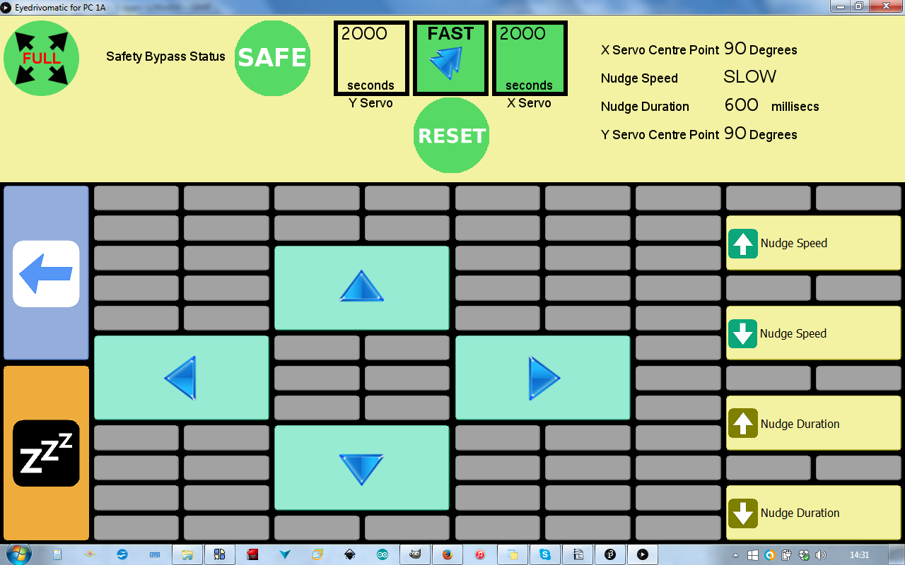

This is where you can specify nudge parameters and adjust the hand centre (rest) position, more on which later.

The First Test

Move to an open space with at least 5 metres clearance all round without any obstacles, stairs or any drops such as kerbs.

TURN WHEELCHAIR OFF

Fitting the electronic hand

- Remove the top of the existing joystick, including any dust shroud, leave just the rubber gaiter. You should now have just a thin metal shaft.
- Using the double sided foam tape, stick the locator plate centrally over the joystick. Adjust the outer ring, so the screw is facing right from the user's perspective, and the four studs are square relative to the joystick unit.
- Place the mechanical hand on the plate with the servos on the left from the user’s perspective, ensuring the 4 studs are through the holes on the hand's frame.
- Using the Velcro straps, tie the hand tightly around the controller.
- If necessary, manually move the hand's arm centrally over the joystick shaft then select the tightest fitting mushroom and slide it through the hole in the arm a over the shaft as far down as possible.

Select the button you added in preparation stage to launch Eyedrivomatic

Make sure the battery pack is on.

If necessary, go to the trim grid and use the arrows to centre the joystick.

On the setup grid turn safety mode OFF.

Go to the driving grid and set both durations to 2 seconds and speed to WALK. Select FULL diagonal mode.

Making sure the WHEELCHAIR IS OFF, push each of the direction buttons and check there's a corresponding hand movement.

Change both durations to 0.5 seconds and speed to SLOW. Turn wheelchair on and select the controller's lowest speed.

Push forward and assess the resulting movement. With these settings the movement should be EXTREMELY slight or none. If it moved significantly, PROGRESS NO FURTHER until you have contacted us via the Hackaday website.

Assuming the movement was slight or none, test backwards and diagonals. When testing right and left be aware that the wheelchair might respond quicker than other directions.

If you're happy with this stage, increase the speed to WALK and test again.

If you're still happy, increase both durations to 1 second and test again.

If the wheelchair movement isn't sufficient on WALK combined with controller speed 1, change Eyedrivomatic speed back to SLOW and increase the controller's speed up a level.

Keep proceeding like this until you feel comfortable with the WALK speed.
The final stage in this stage of testing is possibly the fiddliest, adjusting the trim. Once you're confident enough to drive a few metres you will probably notice the wheelchair isn't driving straight. (NOTE: When you first start driving, the wheelchair won’t necessarily initially move in the precise desired direction, because the wheelchair’s castor wheels may need to straighten or flip direction. During this process the wheelchair will take a short time to steer true)

There are two methods of correcting this. The first is using the trim grid; the second is by turning the adjustable plate which the hand sits on. You will probably need to do a little of both to achieve a straight, forward course AND achieve a balance between right and left movements to ensure both directions turn equally.

